Editing the master slide – Powerpoint Presentation

On the powerpoint presentation window, click view in the menu items. This will change the icon set container to present the view sub menus. Under the master views category, click the Slide Master icon.

Click view on the menu

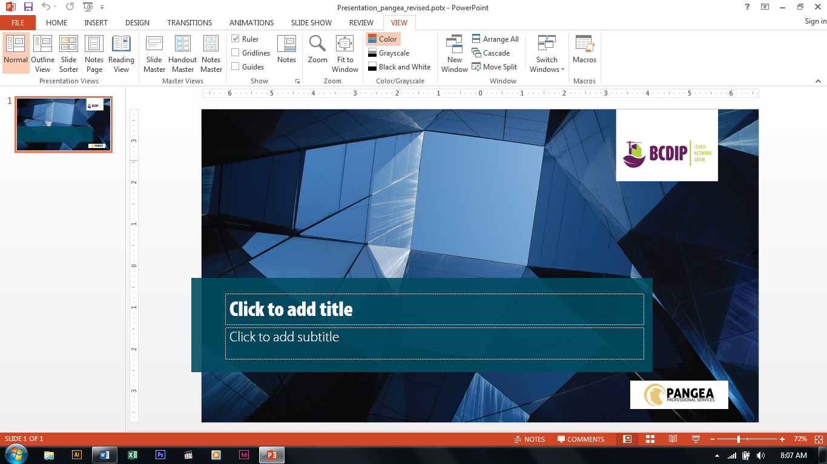

Click the slide master

The slide master template will open showing all the page layouts associated with the template

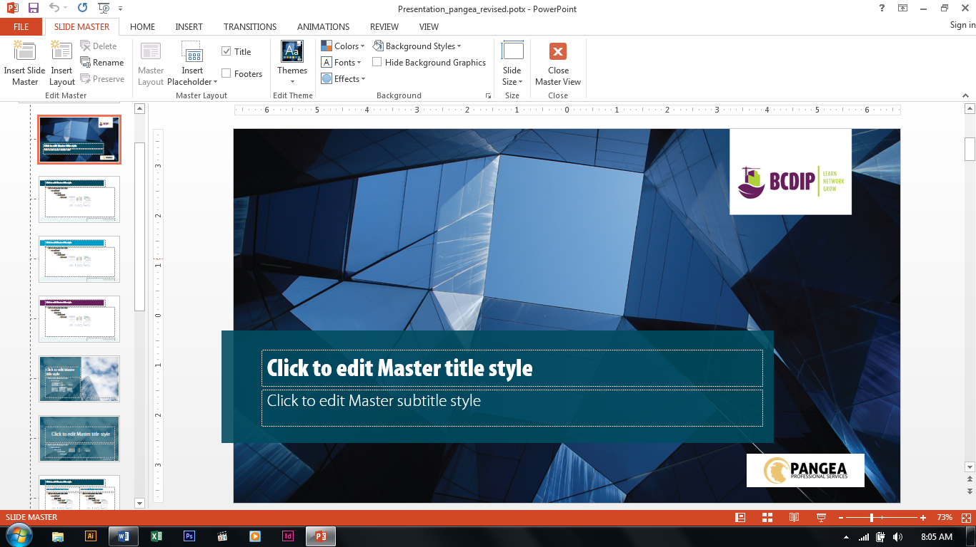

Pages layouts for the template

Through the page layouts, one can change the header, footer of any page style that they wish to be by clicking the page and editing it.

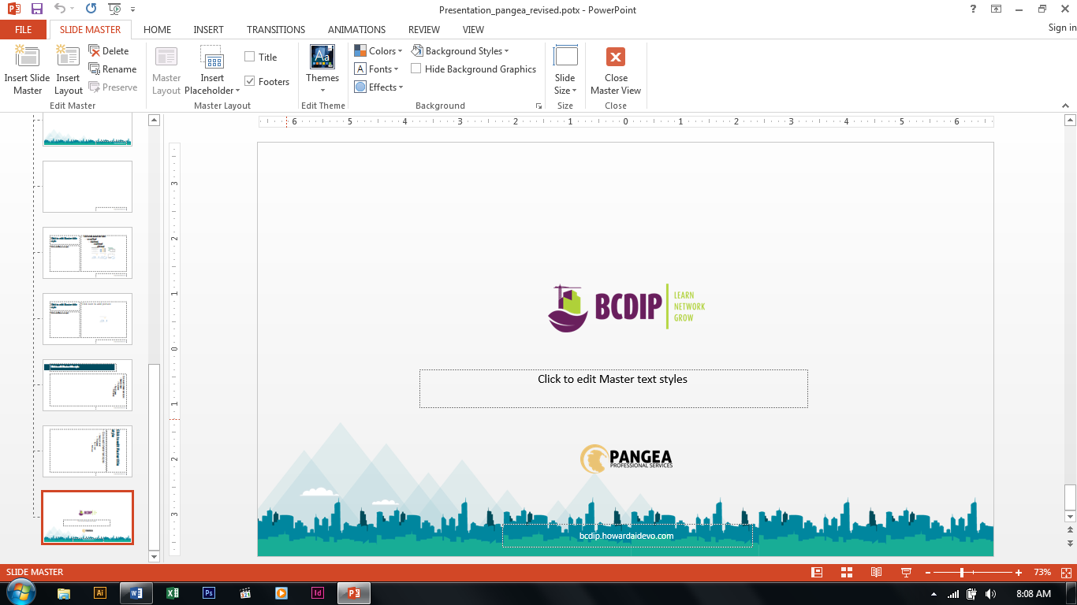

Content is editable and one can add the partner logos or remove them

Last page in the list (last page with logos) is clicked

After editing the master slide, to close it and test the new/updated layout, click on the close master view on the menu tab

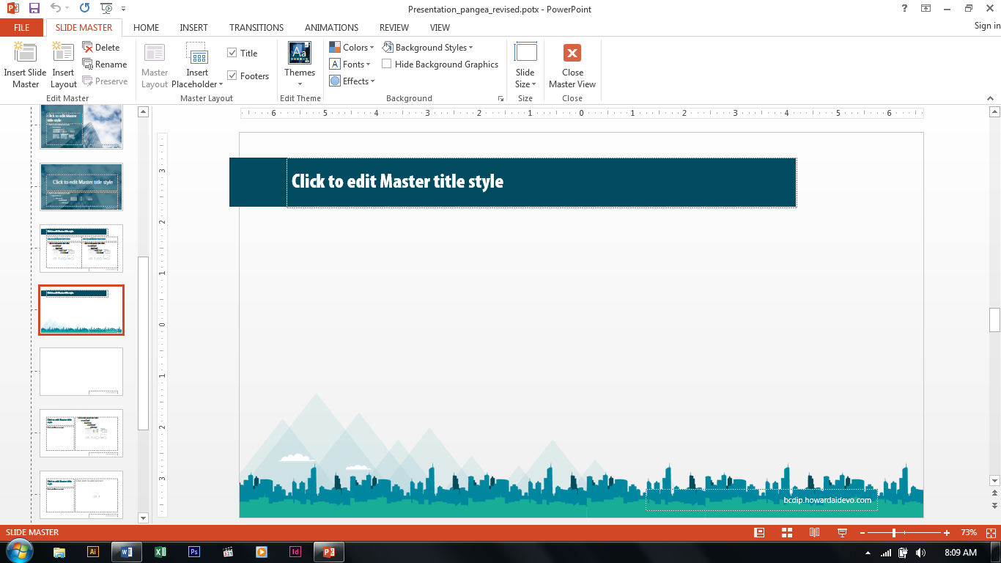

The window should return to the original state with the pages that you have created presented on the left panel of the window. To change the layout of the page being created, right click the page on the left panel and under the dropdown menu, select layout. This will show all the master slide layouts for the powerpoint presentation template.

